Lab # 3 — Assessment Worksheet

**Course Name and Number: FRS301**

**Student Name: Tran Thanh Tuan**

**Student Id: SE161095**

**Instructor Name: Nguyen Van Vinh**

## **Create Virtual Hard Drive, Delete File, Recover File**

***Log into WXP-SP2***

1. **Start VMware Player**

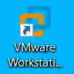

1. **Start Up WXP-SP2**

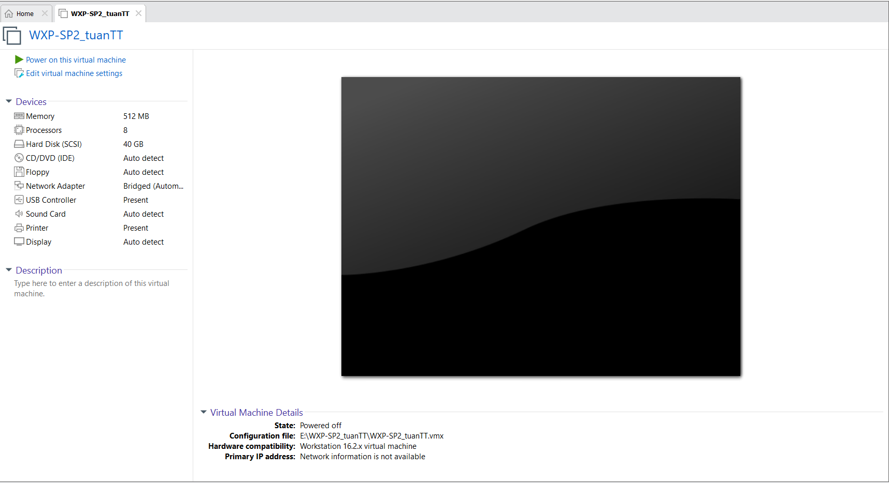

1. **Add Device**

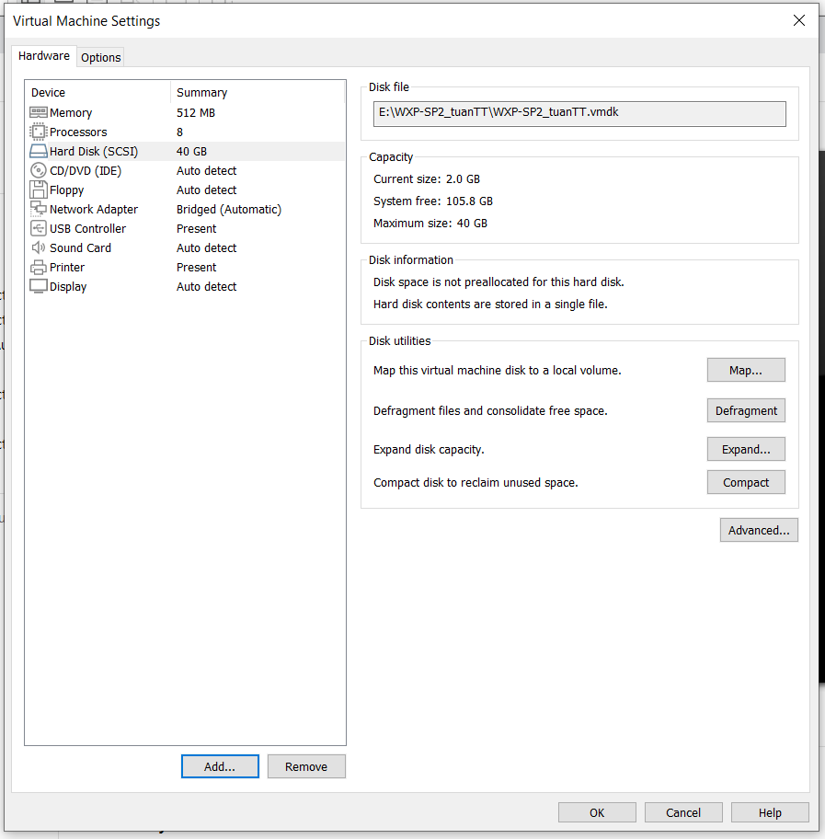

1. **Add Hard Disk**

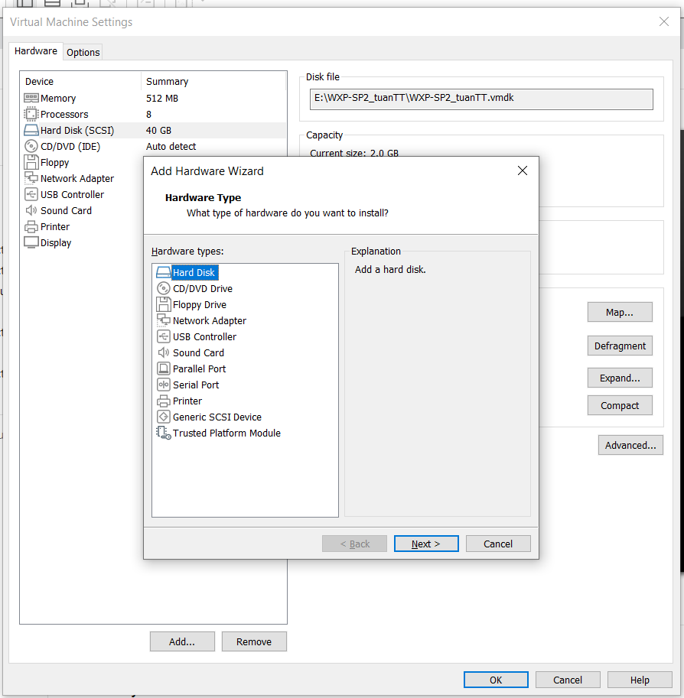

1. **Select a Disk Type**

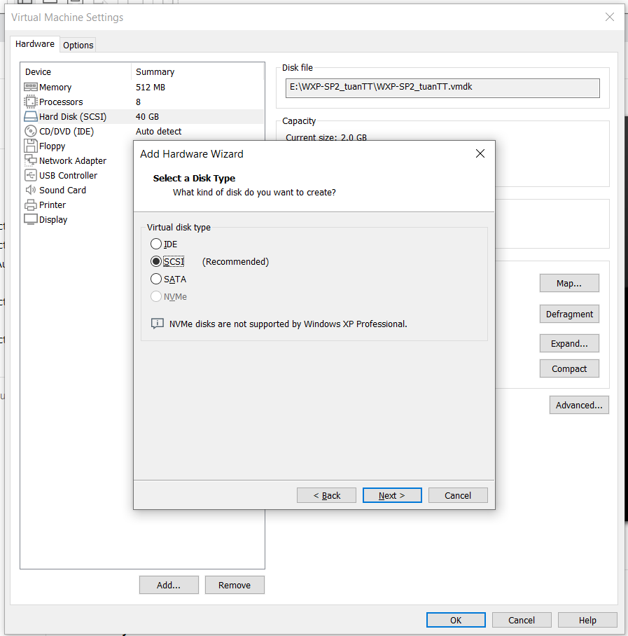

1. **Select a Disk**

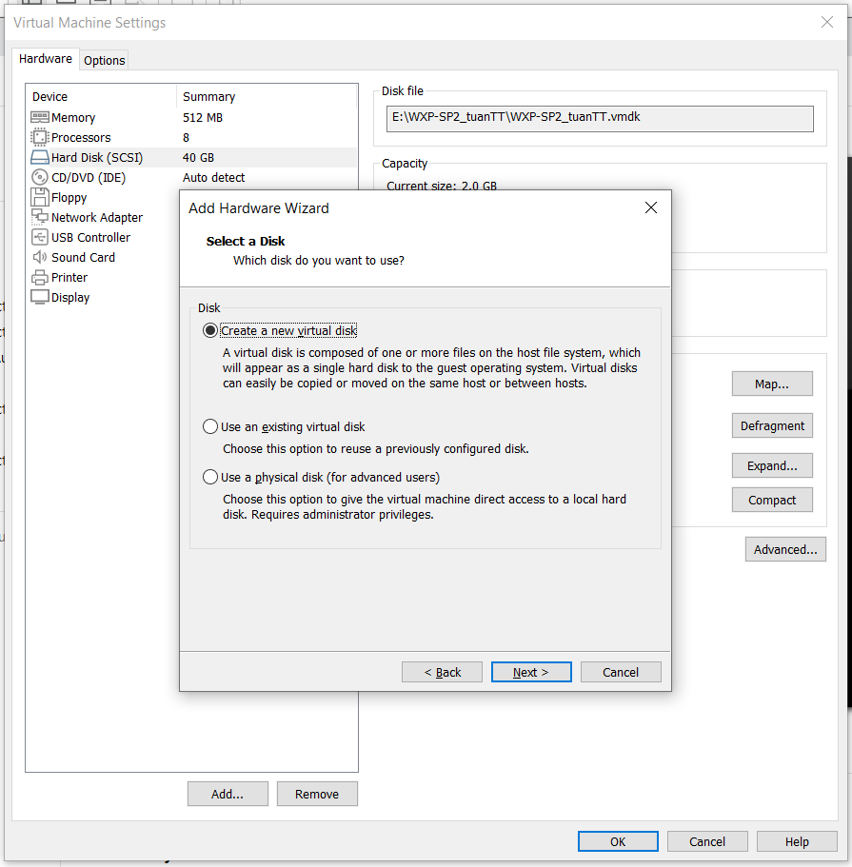

1. **Select Disk Capacity**

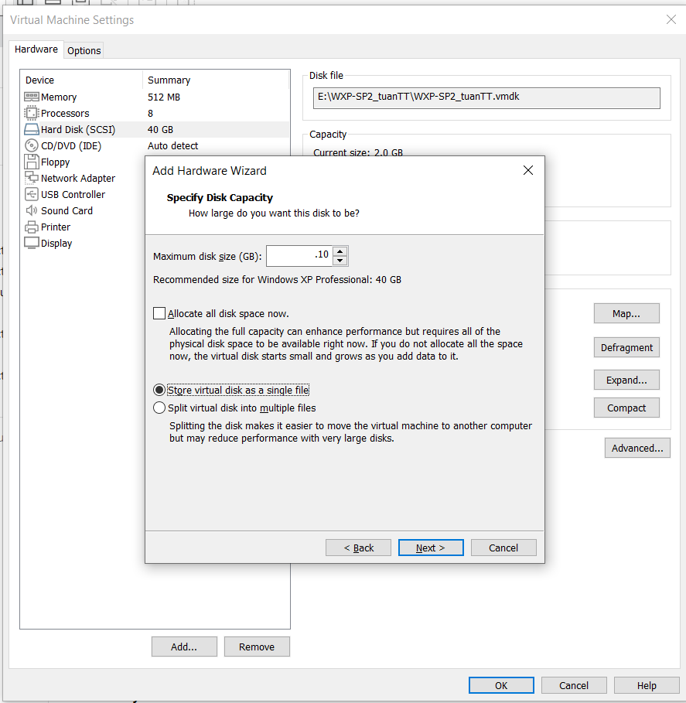

1. **Specify Disk File**

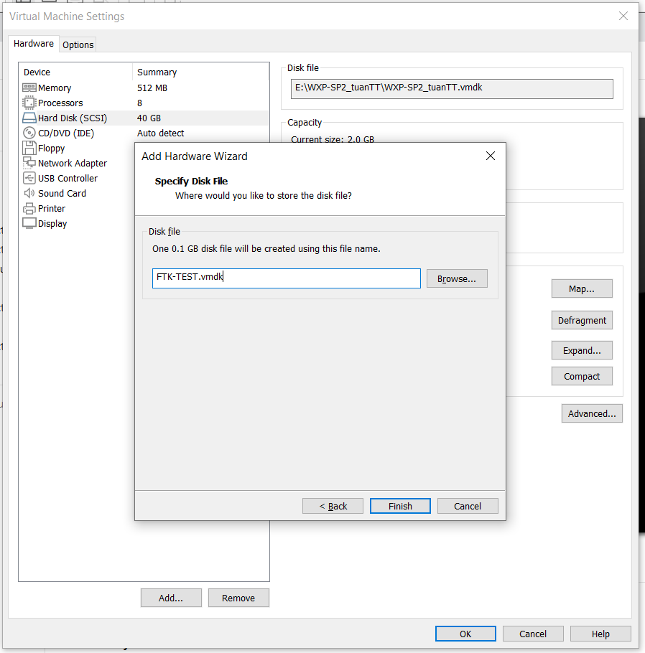

1. **View Results**

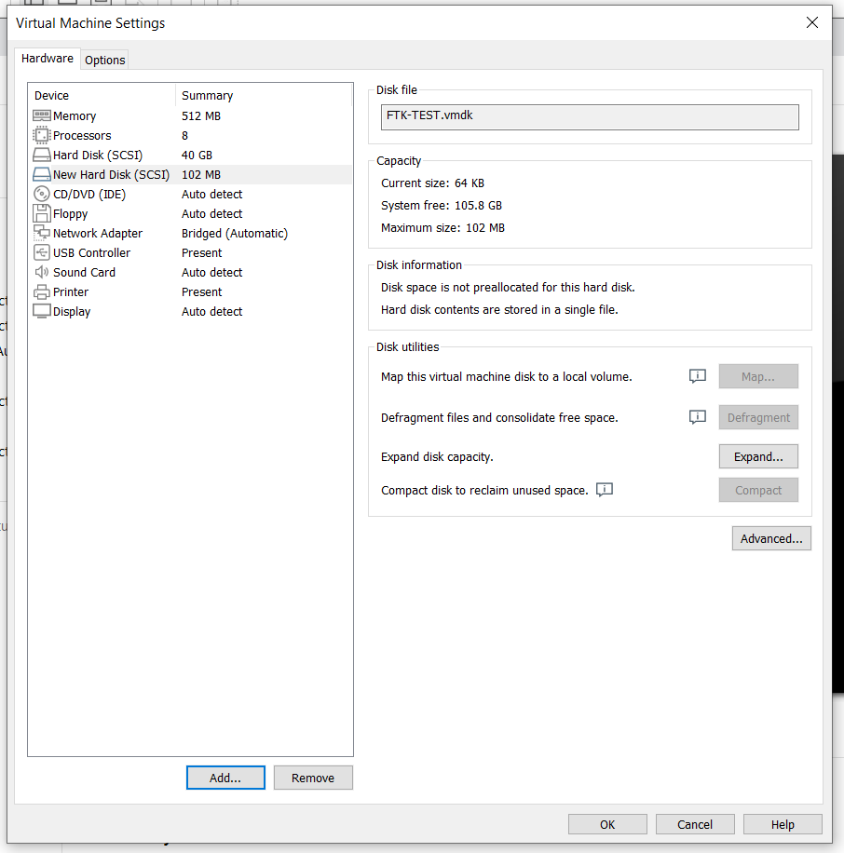

1. **Edit Virtual Machine Settings**

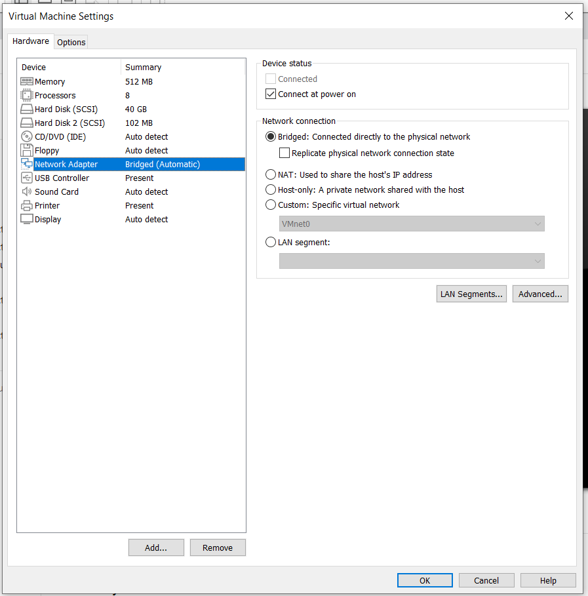

1. **Play Virtual Machine**



1. **Open a Command Prompt**



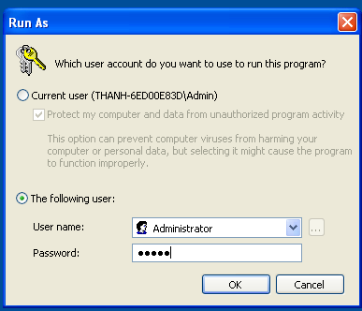

1. **Obtain WXP-SP2's IP Address**

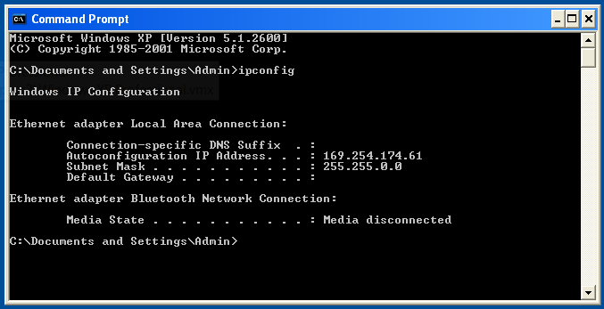

***Format New Hard Disk***

1. **Open Computer Management**

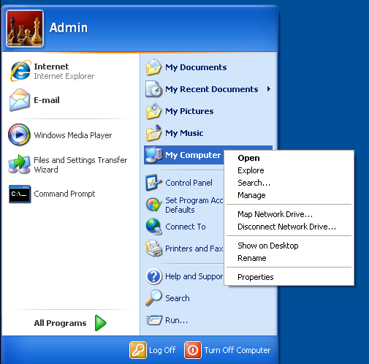

1. **Disk Management**

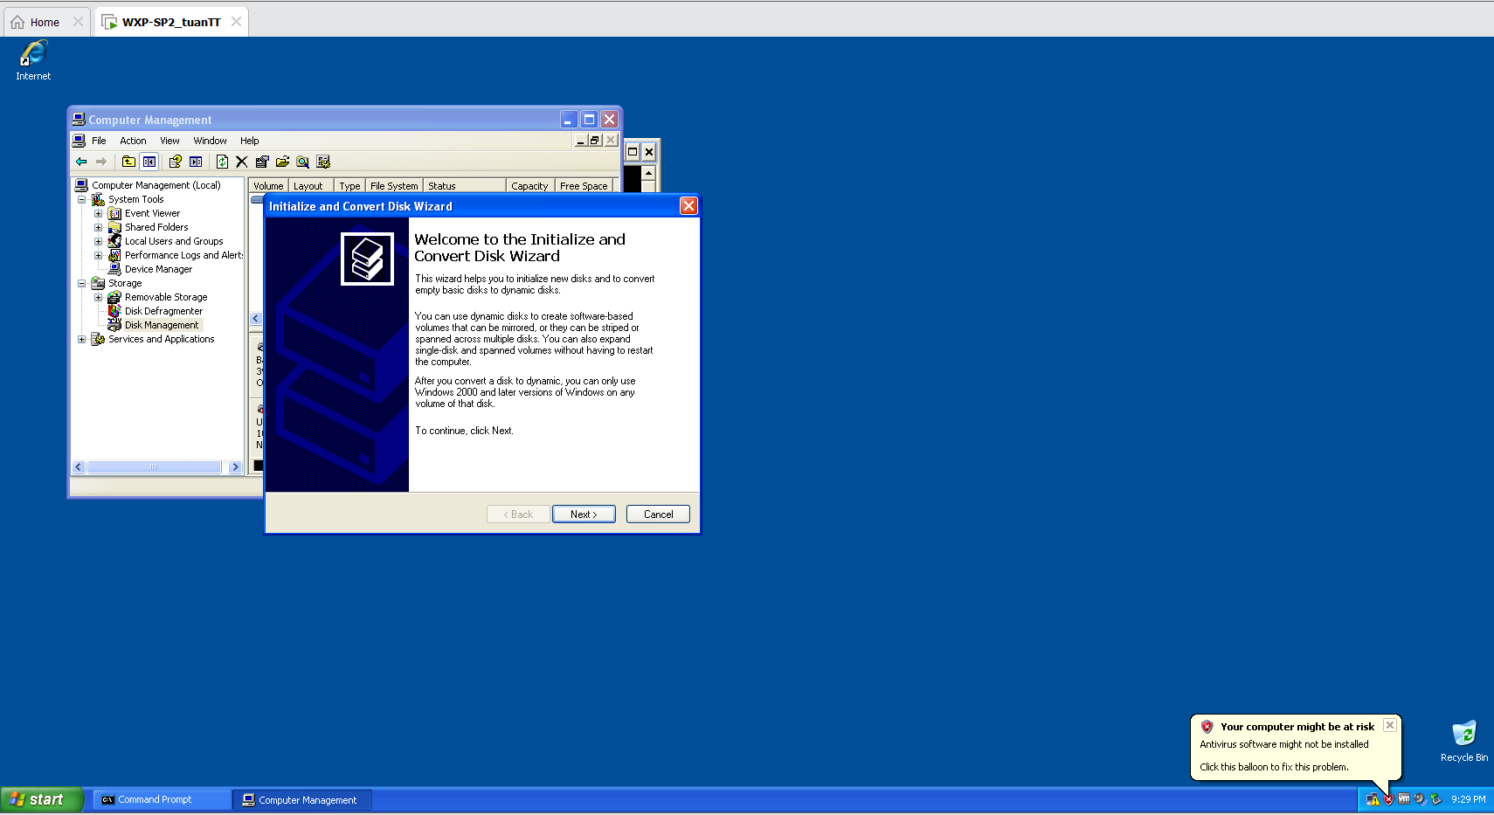

1. **Select Disks to Initialize**

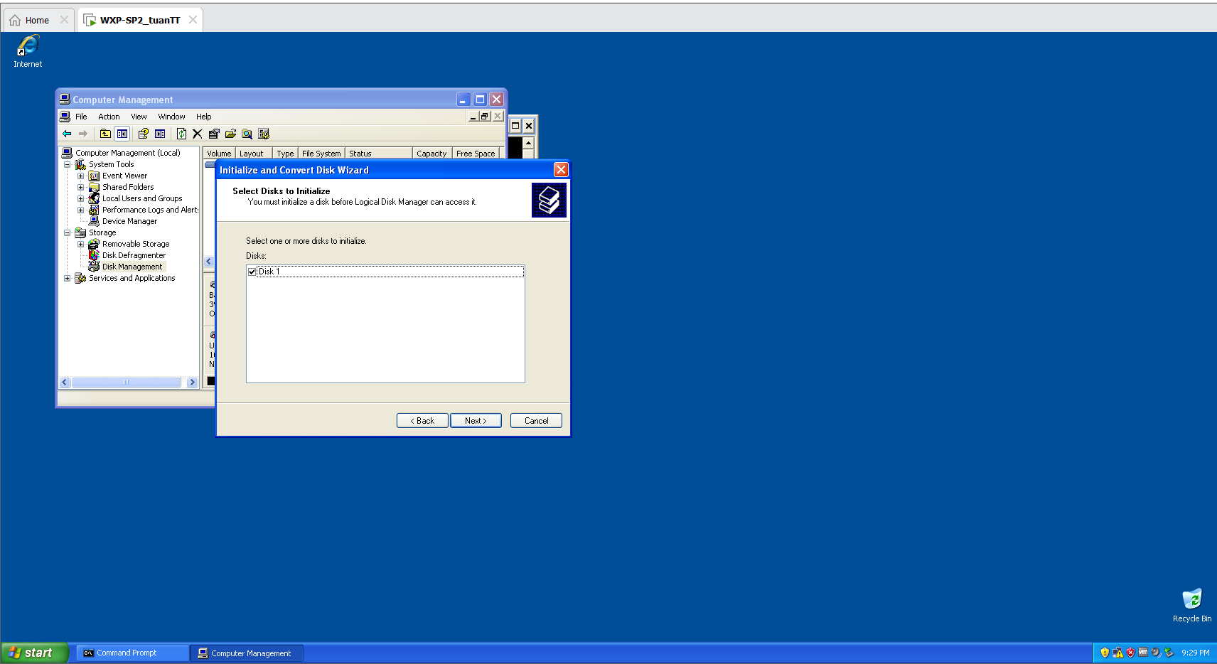

1. **Select Disks to Convert**

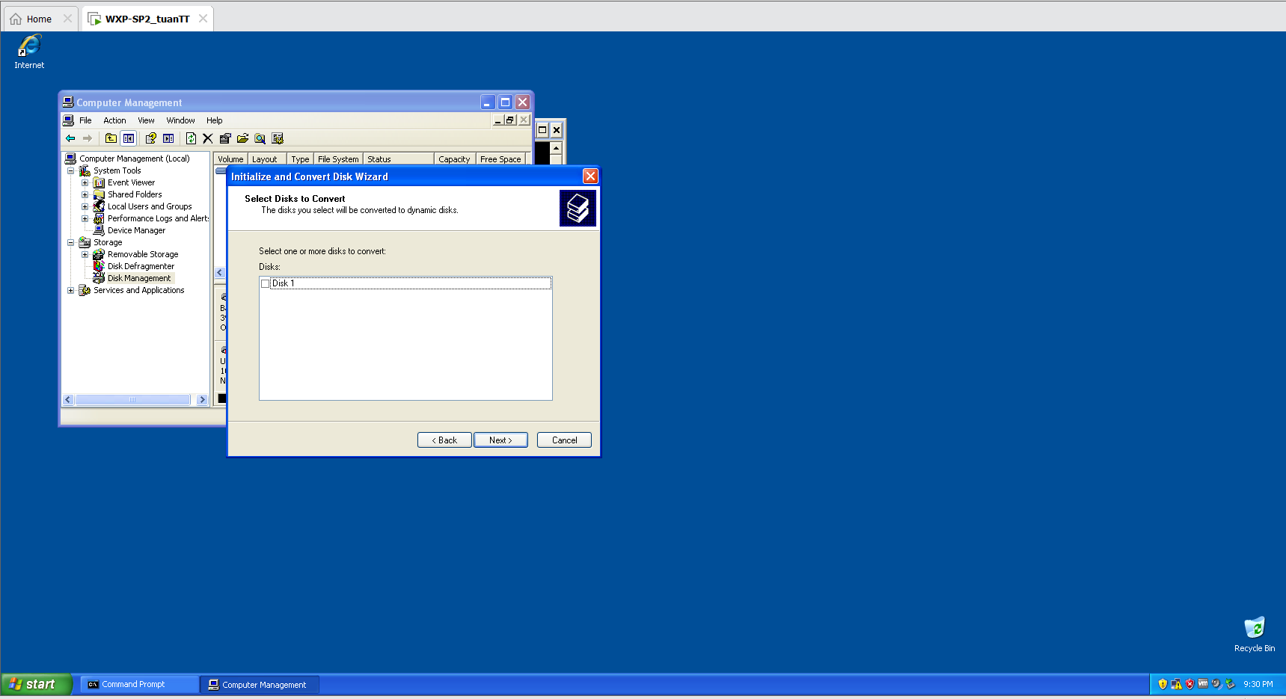

1. **Complete Disk Wizard**

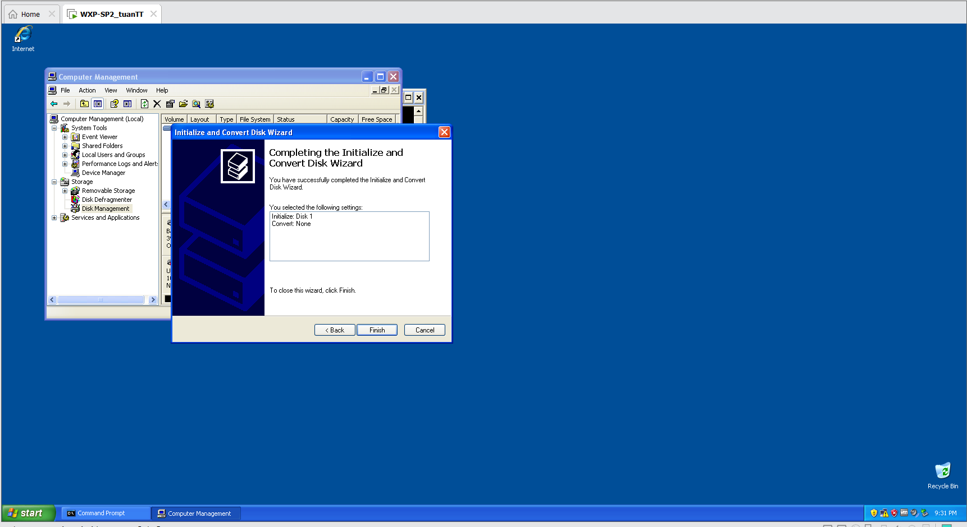

1. **Create New Partition**

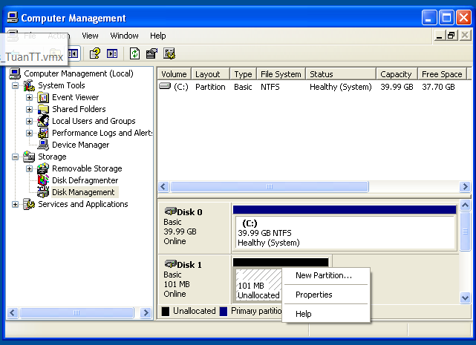

1. **New Partition Wizard**

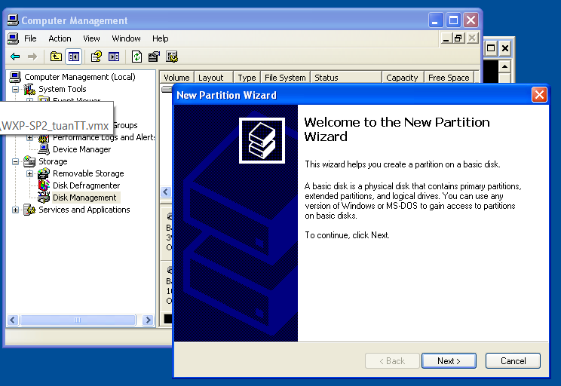

1. **Select Partition Type**

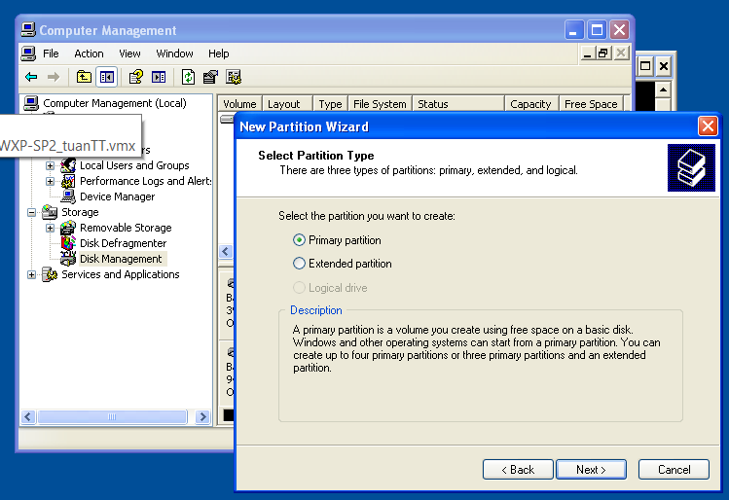

1. **Specify Partition Size**

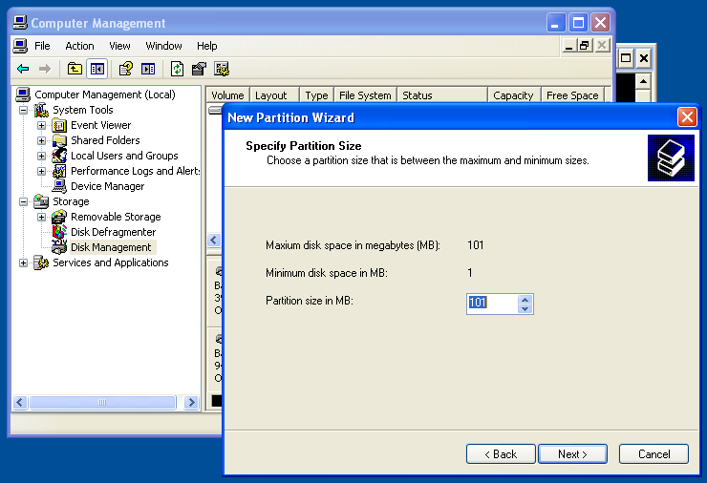

1. **Assign Drive Letter or Patch**

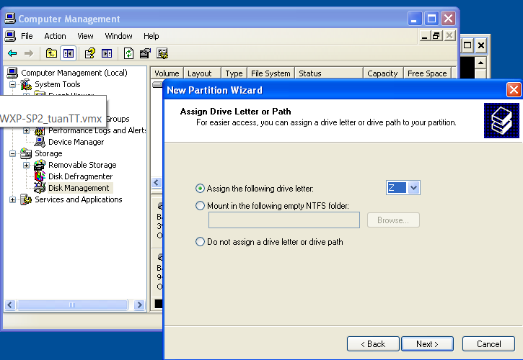

1. **Format Partition**

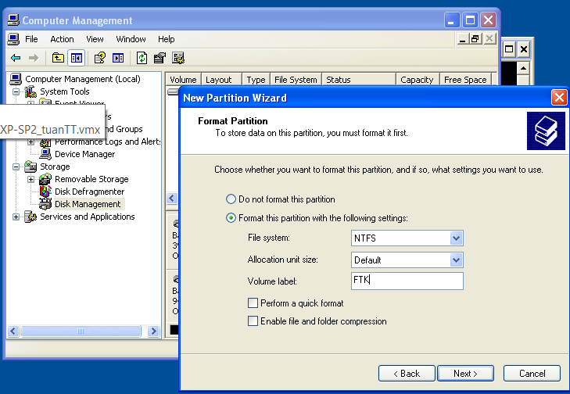

1. **Complete the New Partition Wizard**

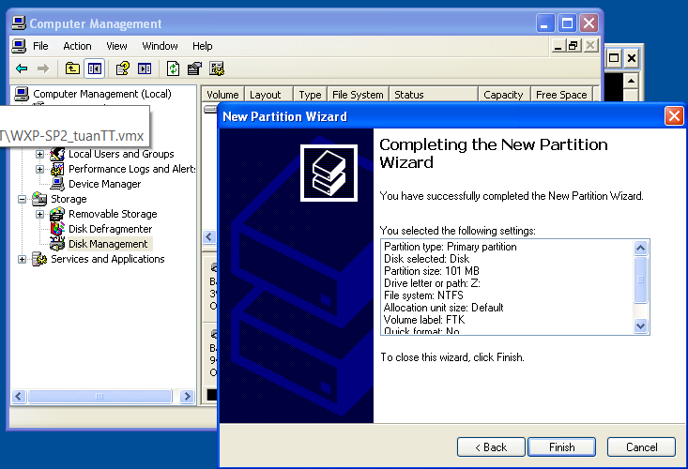

1. **Verify Results**

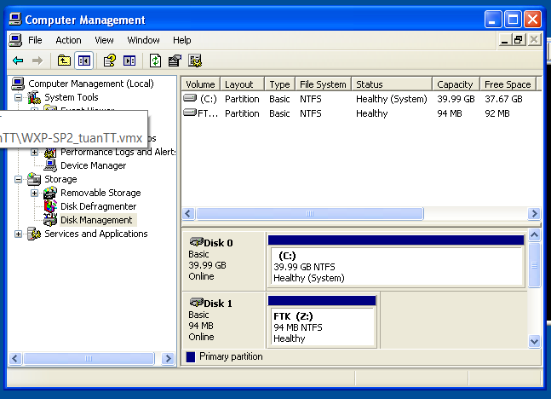

***Download Test Picture***

1. **Start Test Picture Download**

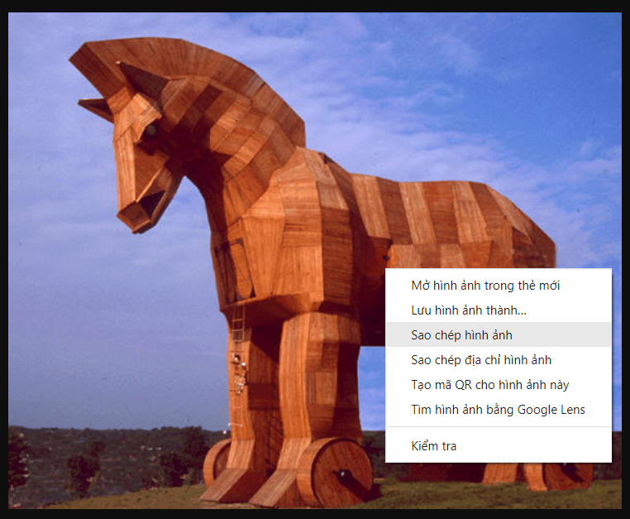

1. **Save Test Picture Download**

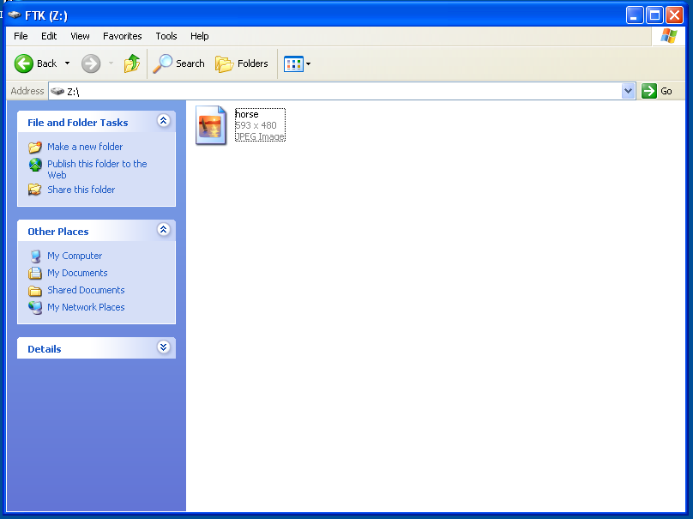

1. **Delete the Test Image**

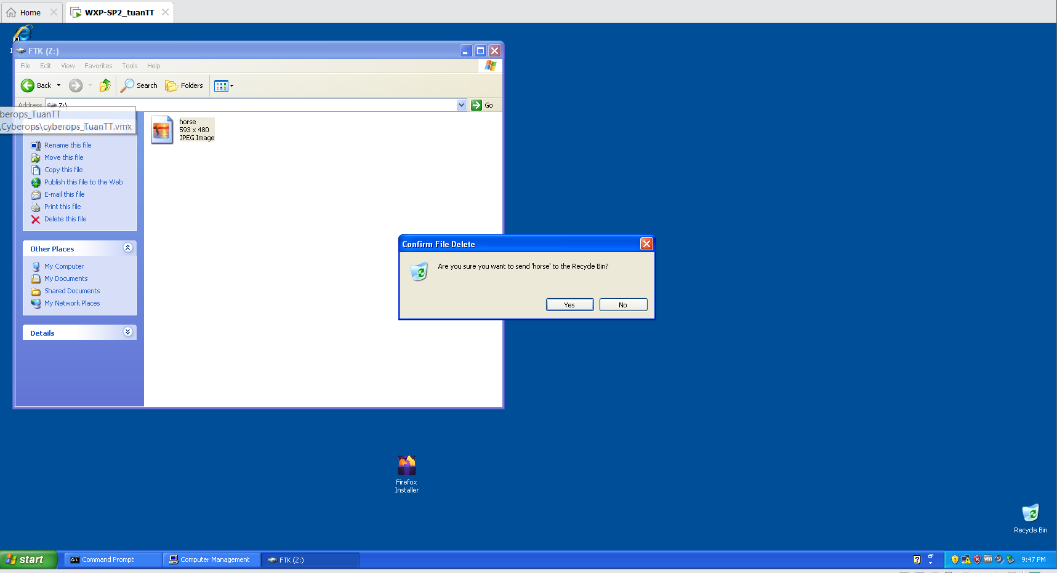

1. **Delete the Test Picture From the Recycle Bin**

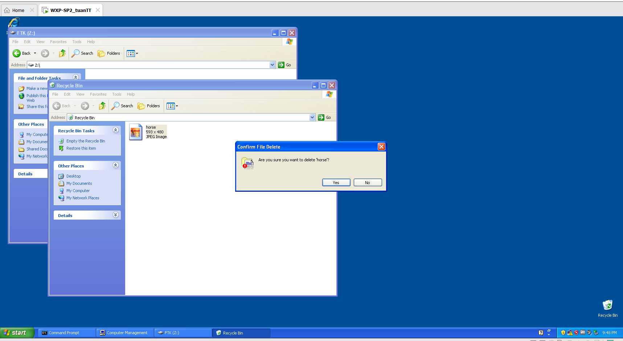

***Forensics Directory***

1. **Create a Forensics Directory**

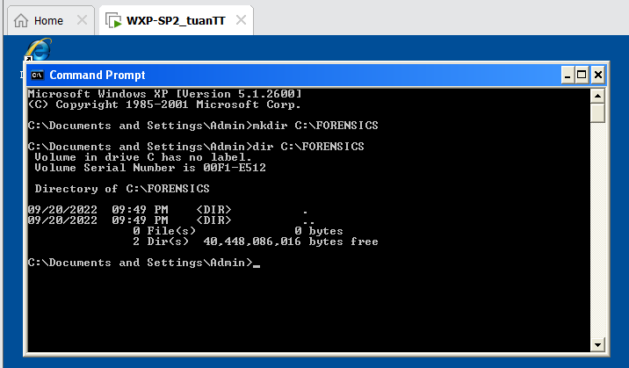

***Start FTK Imager***

1. **Start FTK Imager**

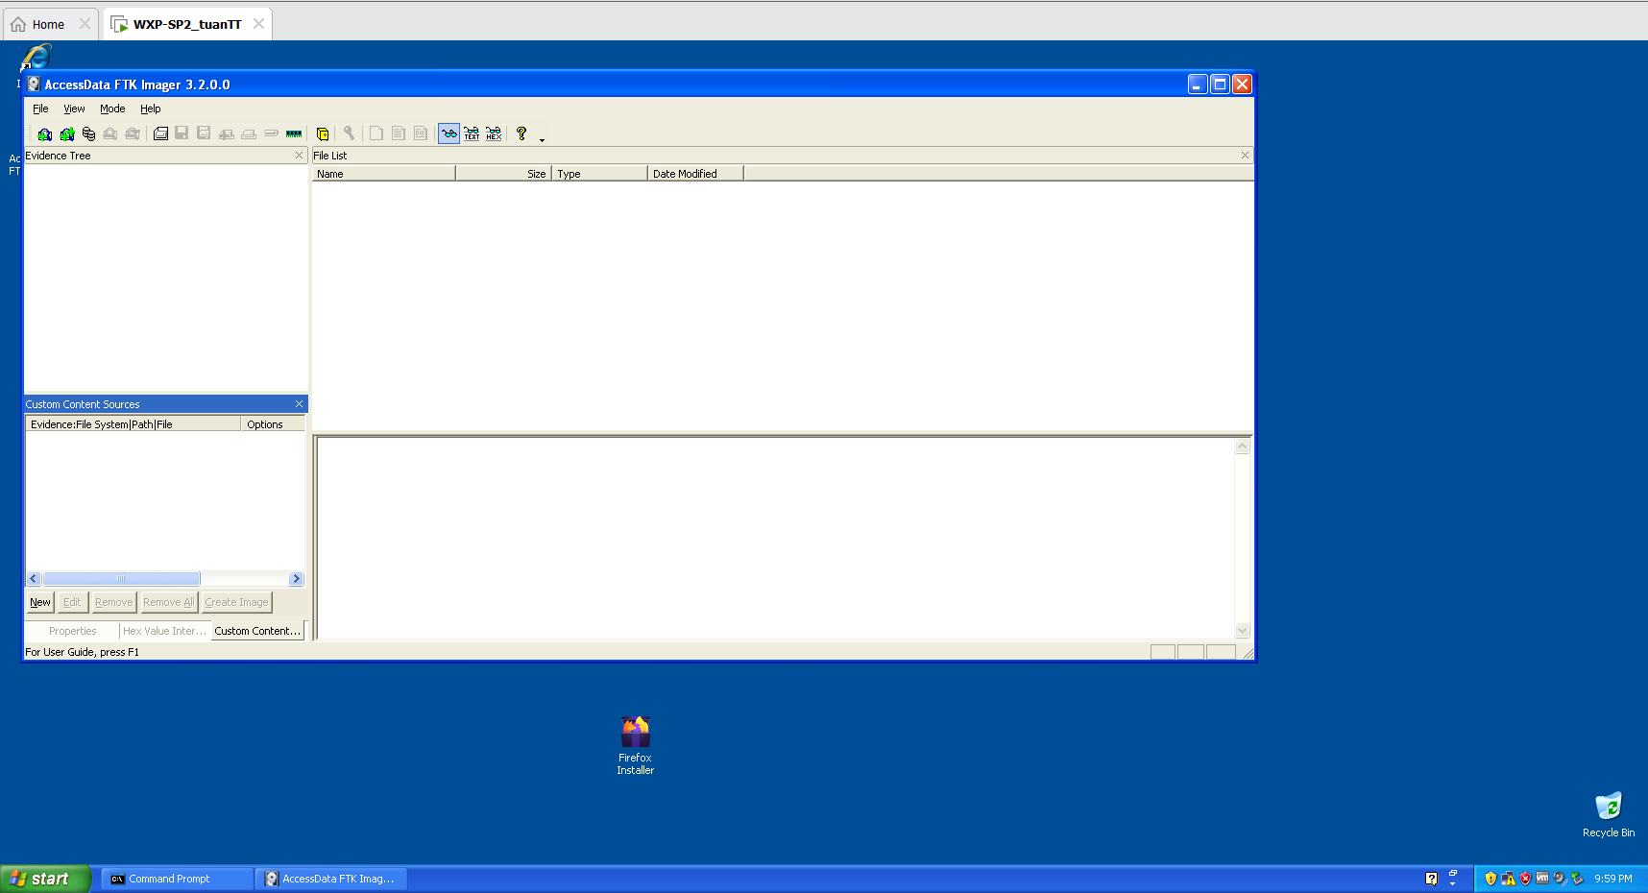

***FTK Imager: Add Evidence Item***

1. **Add Evidence**

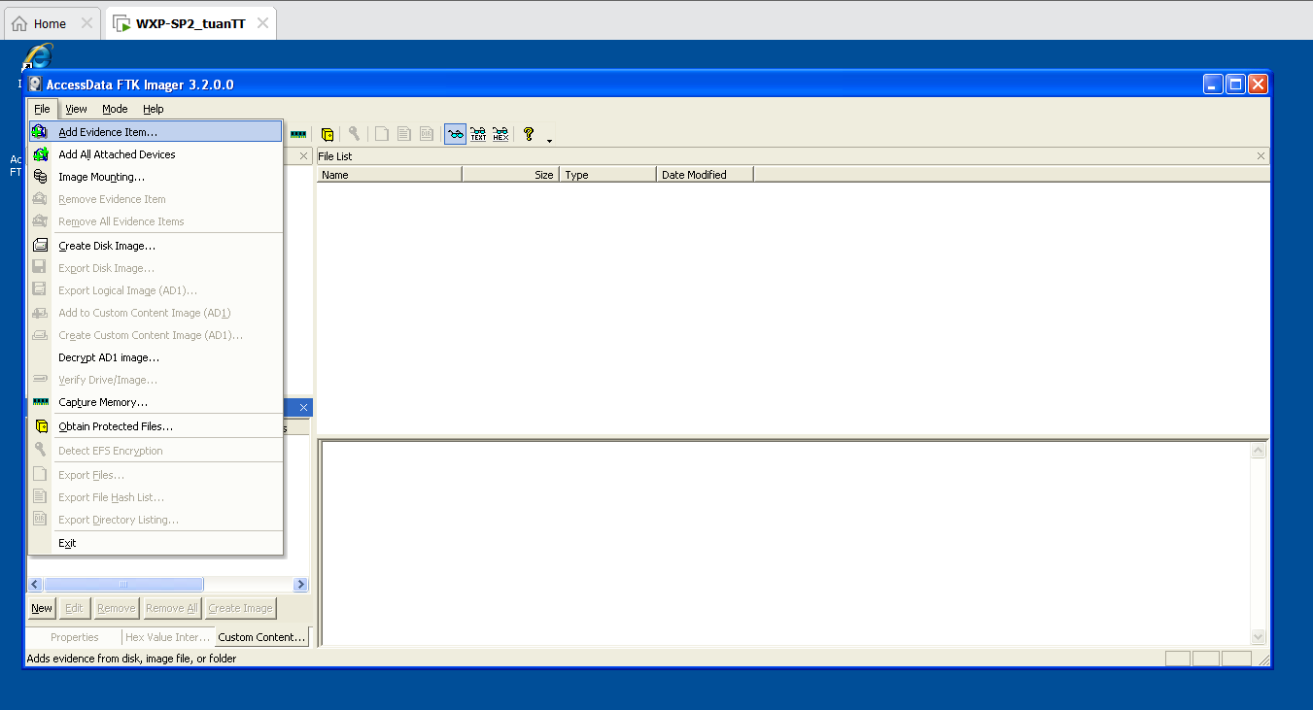

1. **Select Source**

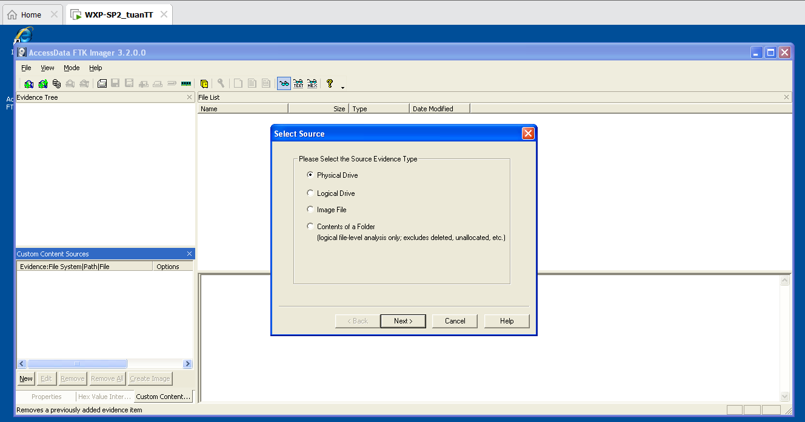

1. **Select Drive**

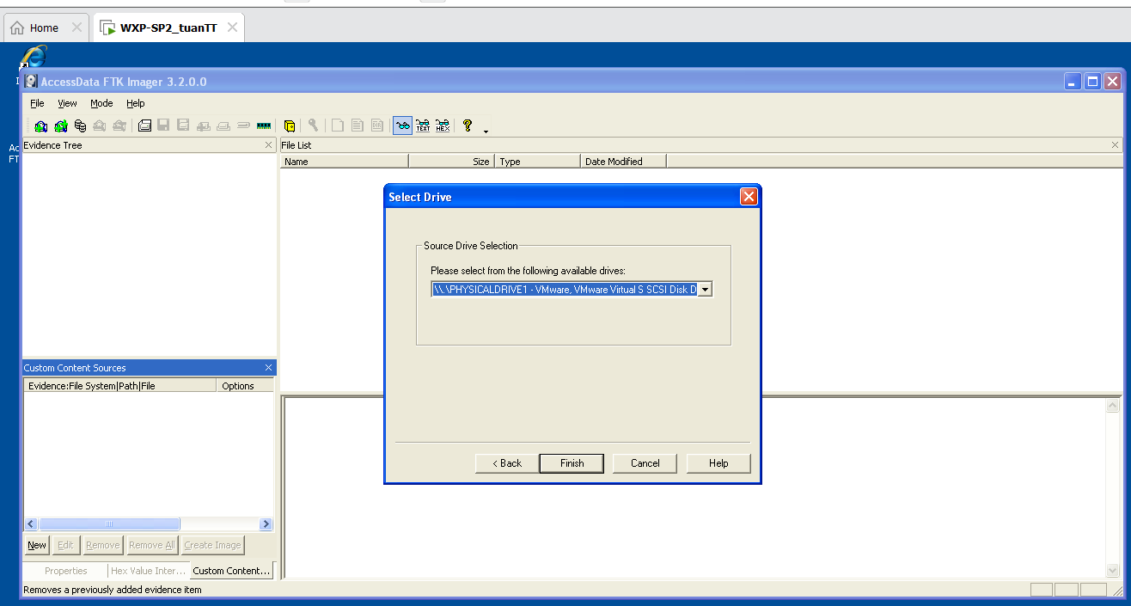

1. **View Deleted Picture**

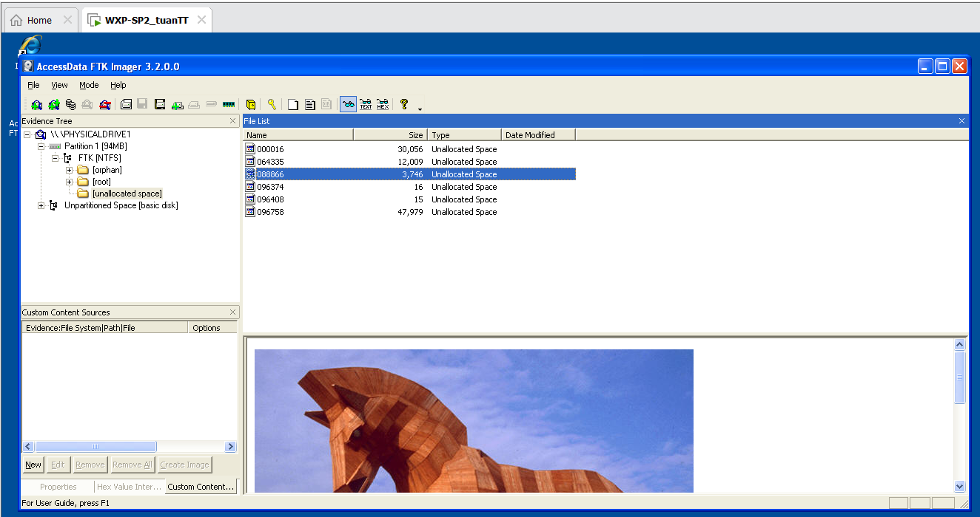

1. **Export File**

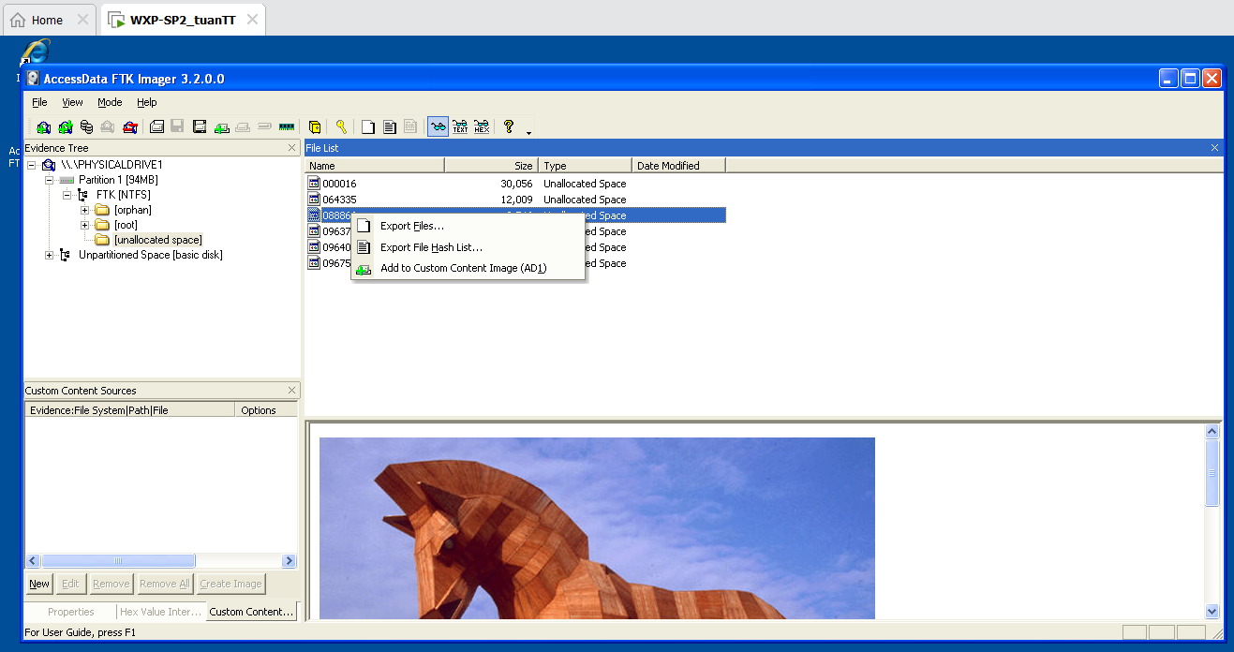

1. **Browse For Folder**

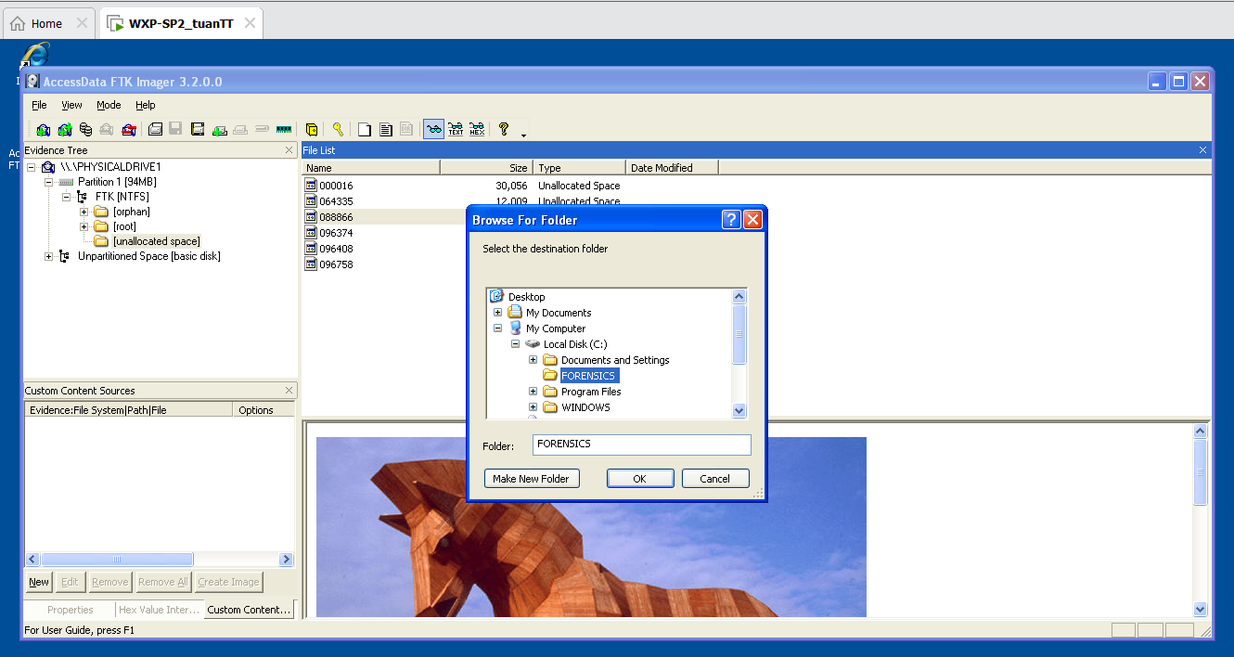

1. **Export Results**

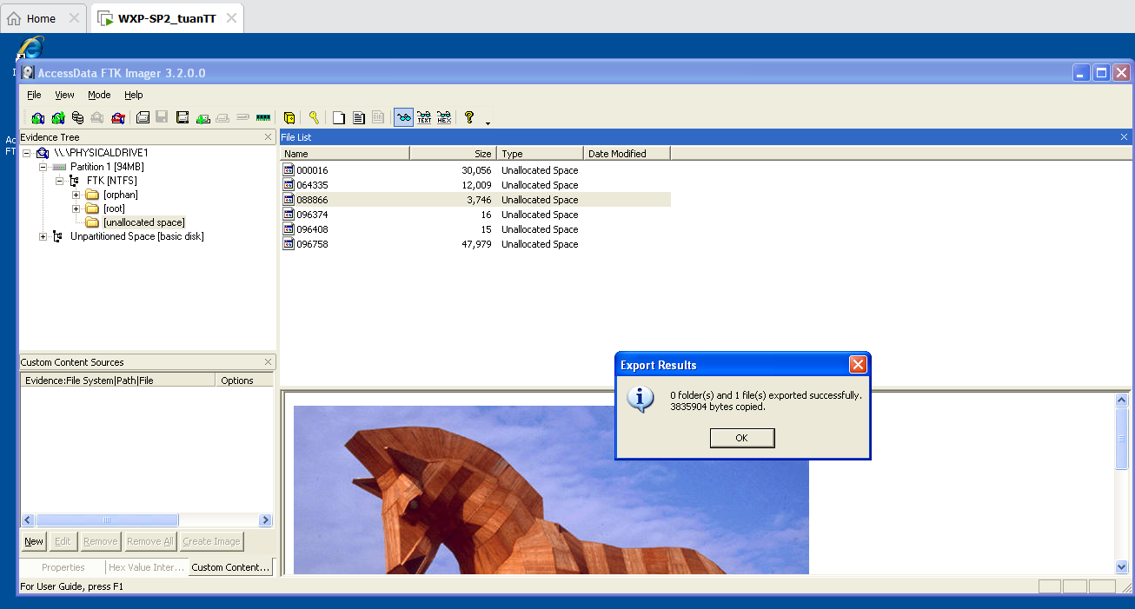

***View Recovered Picture***

1. **Rename File**

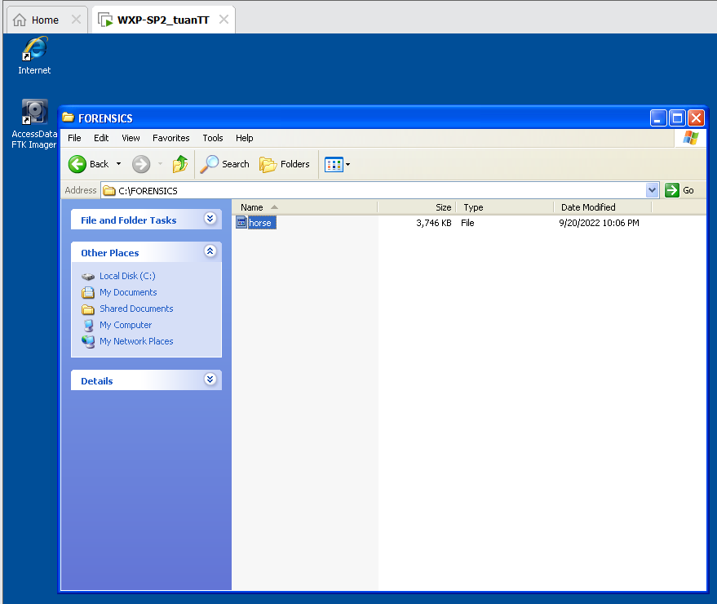

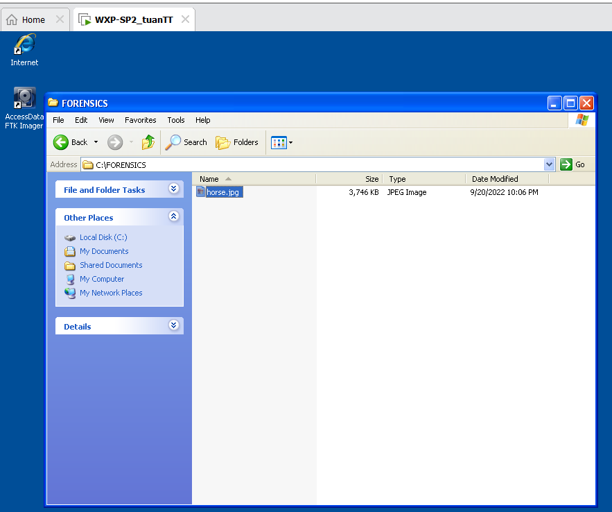

1. **Open My Computer**

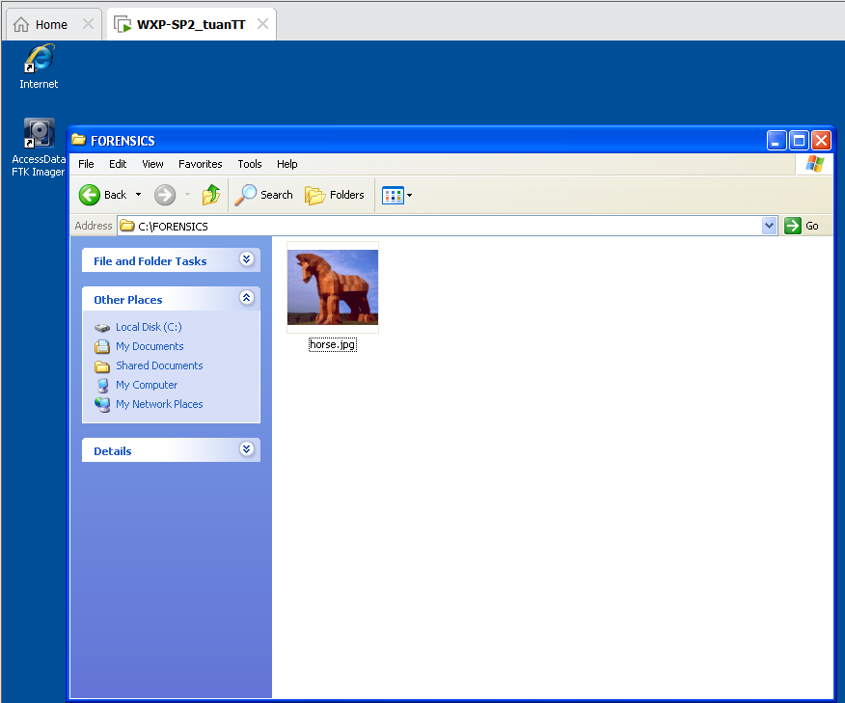

1. **View Picture**

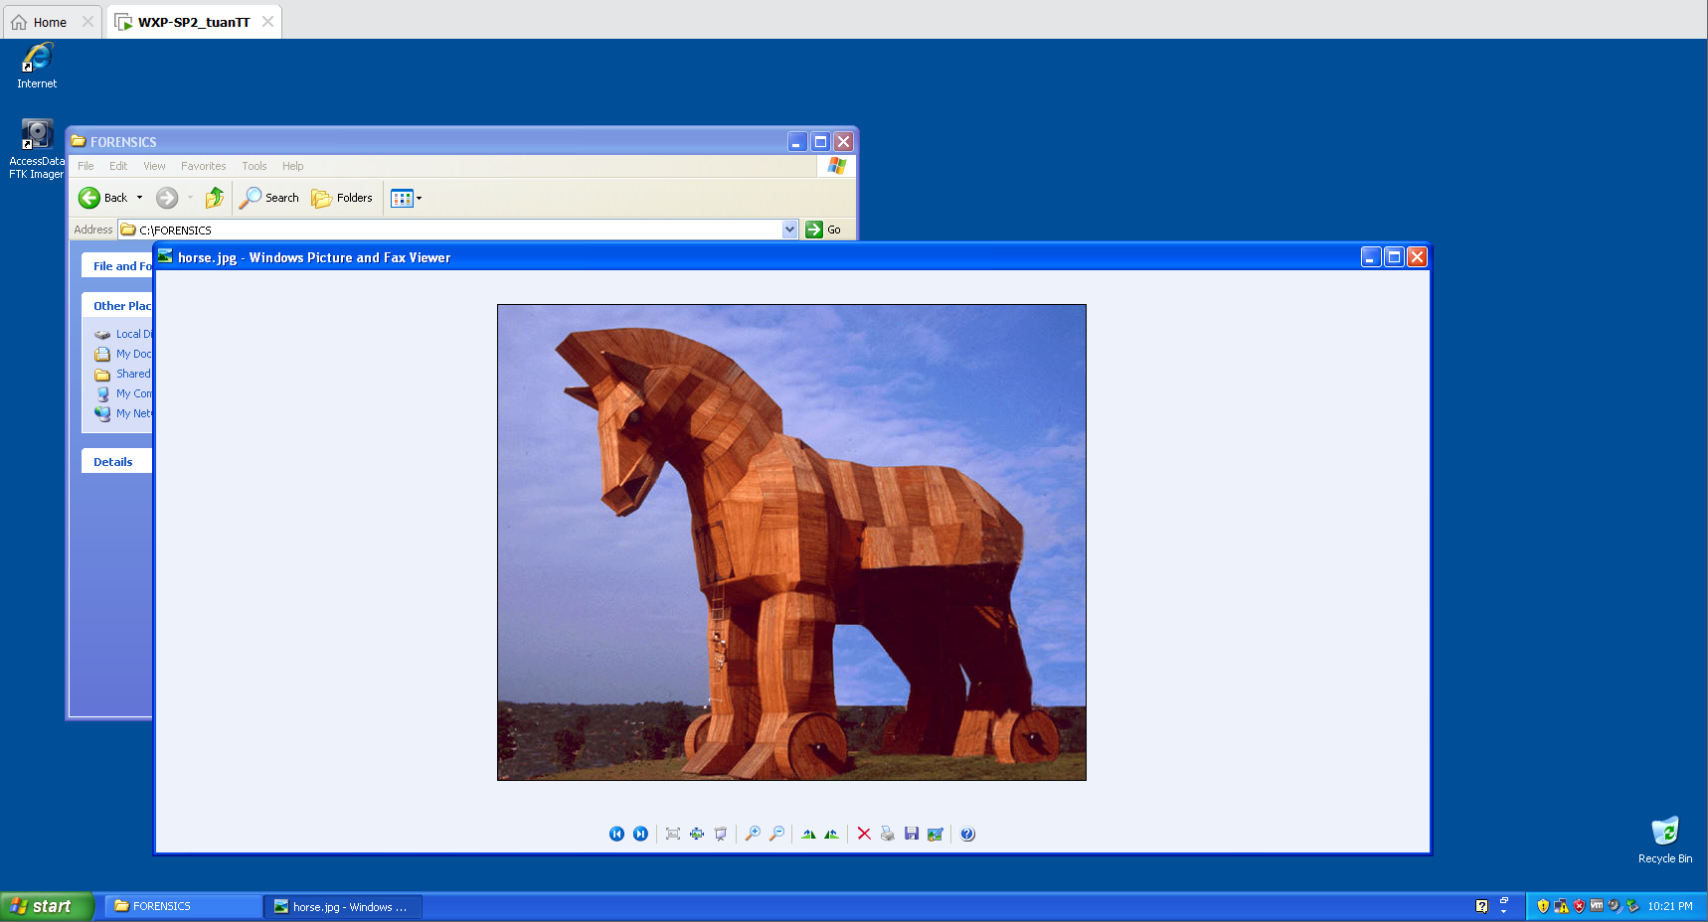

***Proof of Lab***

1. **Proof of Lab**

